MODULE 4
- Introduction to AWT & Swing
- Creating a JFrame
- Simple GUI with Text Field, Button.

- Introduction to AWT
Java AWT (Abstract Window Toolkit) is an API to develop Graphical User Interface (GUI) or windows-based applications in Java.
Java AWT components are platform-dependent i.e. components are displayed according to the view of operating system. AWT is heavy weight i.e. its components are using the resources of underlying operating system (OS).
The java.awt package provides classes for AWT API such as TextField, Label, TextArea, RadioButton, CheckBox, Choice, List etc.
The AWT tutorial will help the user to understand Java GUI programming in simple and easy steps.

Why AWT is platform independent?
Java AWT calls the native platform calls the native platform (operating systems) subroutine for creating API components like TextField, ChechBox, button, etc.
For example, an AWT GUI with components like TextField, label and button will have different look and feel for the different platforms like Windows, MAC OS, and Unix. The reason for this is the platforms have different view for their native components and AWT directly calls the native subroutine that creates those components.
In simple words, an AWT application will look like a windows application in Windows OS whereas it will look like a Mac application in the MAC OS.

Java AWT Hierarchy
The hierarchy of Java AWT classes are given below.
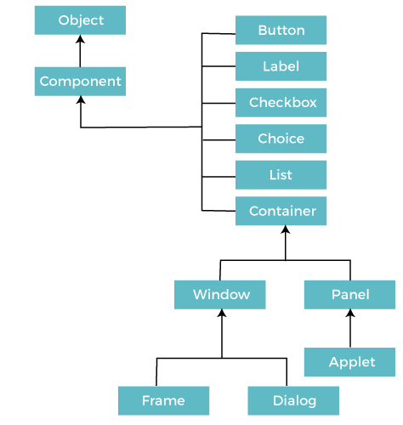

Components
All the elements like the button, text fields, scroll bars, etc. are called components. In Java AWT, there are classes for each component as shown in above diagram. In order to place every component in a particular position on a screen, we need to add them to a container.

Container
The Container is a component in AWT that can contain another components like buttons, textfields, labels etc. The classes that extends Container class are known as container such as Frame, Dialog and Panel.
It is basically a screen where the where the components are placed at their specific locations. Thus it contains and controls the layout of components.
Types of containers:
There are four types of containers in Java AWT:
- Window
- Panel
- Frame
- Dialog

Window
The window is the container that have no borders and menu bars. You must use frame, dialog or another window for creating a window. We need to create an instance of Window class to create this container.

Panel
The Panel is the container that doesn't contain title bar, border or menu bar. It is generic container for holding the components. It can have other components like button, text field etc. An instance of Panel class creates a container, in which we can add components.

Frame
The Frame is the container that contain title bar and border and can have menu bars. It can have other components like button, text field, scrollbar etc. Frame is most widely used container while developing an AWT application.

Useful Methods of Component Class
Method | Description
public void add(Component c) | Inserts a component on this component.
public void setSize(int width,int height) | Sets the size (width and height) of the component.
public void setLayout(LayoutManager m) | Defines the layout manager for the component.
public void setVisible(boolean status) | Changes the visibility of the component, by default false.

Java AWT Example
To create simple AWT example, you need a frame. There are two ways to create a GUI using Frame in AWT.
- By extending Frame class (inheritance)
- By creating the object of Frame class (association)

AWT Example by Inheritance
Let's see a simple example of AWT where we are inheriting Frame class. Here, we are showing Button component on the Frame.
AWTExample1.java
// importing Java AWT class
import java.awt.*;
// extending Frame class to our class AWTExample1
public class AWTExample1 extends Frame {
// initializing using constructor
AWTExample1() {
// creating a button
Button b = new Button("Click Me!!");
// setting button position on screen
b.setBounds(30,100,80,30);
// adding button into frame
add(b);
// frame size 300 width and 300 height
setSize(300,300);
// setting the title of Frame
setTitle("This is our basic AWT example");
// no layout manager
setLayout(null);
// now frame will be visible, by default it is not visible
setVisible(true);
}
// main method
public static void main(String args[]) {
// creating instance of Frame class
AWTExample1 f = new AWTExample1();
}
}
download this example
The setBounds(int x-axis, int y-axis, int width, int height) method is used in the above example that sets the position of the awt button.

Output:
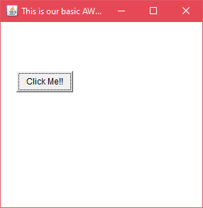

AWT Example by Association
Let's see a simple example of AWT where we are creating instance of Frame class. Here, we are creating a TextField, Label and Button component on the Frame.
AWTExample2.java
// importing Java AWT class
import java.awt.*;
// class AWTExample2 directly creates instance of Frame class
class AWTExample2 {
// initializing using constructor
AWTExample2() {
// creating a Frame
Frame f = new Frame();
// creating a Label
Label l = new Label("Employee id:");
// creating a Button
Button b = new Button("Submit");
// creating a TextField
TextField t = new TextField();
// setting position of above components in the frame
l.setBounds(20, 80, 80, 30);
t.setBounds(20, 100, 80, 30);
b.setBounds(100, 100, 80, 30);
// adding components into frame
f.add(b);
f.add(l);
f.add(t);
// frame size 300 width and 300 height
f.setSize(400,300);
// setting the title of frame
f.setTitle("Employee info");
// no layout
f.setLayout(null);
// setting visibility of frame
f.setVisible(true);
}
// main method
public static void main(String args[]) {
// creating instance of Frame class
AWTExample2 awt_obj = new AWTExample2();
}
}
download this example
Output:
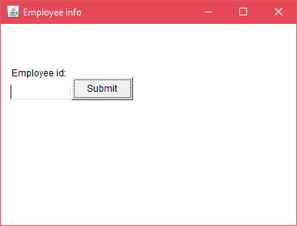
2.Creating a JFrame

Java JFrame
The javax.swing.JFrame class is a type of container which inherits the java.awt.Frame class. JFrame works like the main window where components like labels, buttons, textfields are added to create a GUI.
Unlike Frame, JFrame has the option to hide or close the window with the help of setDefaultCloseOperation(int) method.

Nested Class
Modifier and Type | Class | Description
protected class | JFrame.AccessibleJFrame | This class implements accessibility support for the JFrame class.

Fields
Modifier and Type | Field | Description
protected AccessibleContext | accessibleContext | The accessible context property.
static int | EXIT_ON_CLOSE | The exit application default window close operation.
protected JRootPane | rootPane | The JRootPane instance that manages the contentPane and optional menuBar for this frame, as well as the glassPane.
protected boolean | rootPaneCheckingEnabled | If true then calls to add and setLayout will be forwarded to the contentPane.

Constructors
Constructor | Description
JFrame() | It constructs a new frame that is initially invisible.
JFrame(GraphicsConfiguration gc) | It creates a Frame in the specified GraphicsConfiguration of a screen device and a blank title.
JFrame(String title) | It creates a new, initially invisible Frame with the specified title.
JFrame(String title, GraphicsConfiguration gc) | It creates a JFrame with the specified title and the specified GraphicsConfiguration of a screen device.

Useful Methods
Modifier and Type | Method | Description
protected void | addImpl(Component comp, Object constraints, int index) | Adds the specified child Component.
protected JRootPane | createRootPane() | Called by the constructor methods to create the default rootPane.
protected void | frameInit() | Called by the constructors to init the JFrame properly.
void | setContentPane(Containe contentPane) | It sets the contentPane property
static void | setDefaultLookAndFeelDecorated(boolean defaultLookAndFeelDecorated) | Provides a hint as to whether or not newly created JFrames should have their Window decorations (such as borders, widgets to close the window, title...) provided by the current look and feel.
void | setIconImage(Image image) | It sets the image to be displayed as the icon for this window.
void | setJMenuBar(JMenuBar menubar) | It sets the menubar for this frame.
void | setLayeredPane(JLayeredPane layeredPane) | It sets the layeredPane property.
JRootPane | getRootPane() | It returns the rootPane object for this frame.
TransferHandler | getTransferHandler() | It gets the transferHandler property.

JFrame Example
import java.awt.FlowLayout;
import javax.swing.JButton;
import javax.swing.JFrame;
import javax.swing.JLabel;
import javax.swing.JPanel;
public class JFrameExample {
public static void main(String s[]) {
JFrame frame = new JFrame("JFrame Example");
JPanel panel = new JPanel();
panel.setLayout(new FlowLayout());
JLabel label = new JLabel("JFrame By Example");
JButton button = new JButton();
button.setText("Button");
panel.add(label);
panel.add(button);
frame.add(panel);
frame.setSize(200, 300);
frame.setLocationRelativeTo(null);
frame.setDefaultCloseOperation(JFrame.EXIT_ON_CLOSE);
frame.setVisible(true);
}
}
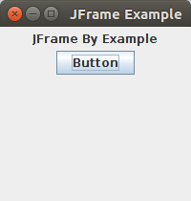
Output

- Simple GUI with Text Field, Button.

Java AWT Button
A button is basically a control component with a label that generates an event when pushed. The Button class is used to create a labeled button that has platform independent implementation. The application result in some action when the button is pushed.
When we press a button and release it, AWT sends an instance of ActionEvent to that button by calling processEvent on the button. The processEvent method of the button receives the all the events, then it passes an action event by calling its own method processActionEvent. This method passes the action event on to action listeners that are interested in the action events generated by the button.
To perform an action on a button being pressed and released, the ActionListener interface needs to be implemented. The registered new listener can receive events from the button by calling addActionListener method of the button. The Java application can use the button's action command as a messaging protocol.

AWT Button Class Declaration
- public class Button extends Component implements Accessible

Button Class Constructors
Following table shows the types of Button class constructors

Sr. no. | Constructor | Description
1. | Button( ) | It constructs a new button with an empty string i.e. it has no label.
2. | Button (String text) | It constructs a new button with given string as its label.

Button Class Methods
Sr. no. | Method | Description
1. | void setText (String text) | It sets the string message on the button
2. | String getText() | It fetches the String message on the button.
3. | void setLabel (String label) | It sets the label of button with the specified string.
4. | String getLabel() | It fetches the label of the button.
5. | void addNotify() | It creates the peer of the button.
6. | AccessibleContext getAccessibleContext() | It fetched the accessible context associated with the button.
7. | void addActionListener(ActionListener l) | It adds the specified action listener to get the action events from the button.
8. | String getActionCommand() | It returns the command name of the action event fired by the button.
9. | ActionListener[ ] getActionListeners() | It returns an array of all the action listeners registered on the button.
10. | T[ ] getListeners(Class listenerType) | It returns an array of all the objects currently registered as FooListeners upon this Button.
11. | protected String paramString() | It returns the string which represents the state of button.
12. | protected void processActionEvent (ActionEvent e) | It process the action events on the button by dispatching them to a registered ActionListener object.
13. | protected void processEvent (AWTEvent e) | It process the events on the button
14. | void removeActionListener (ActionListener l) | It removes the specified action listener so that it no longer receives action events from the button.
15. | void setActionCommand(String command) | It sets the command name for the action event given by the button.

Note: The Button class inherits methods from java.awt.Component and java.lang.Object classes.

Java AWT Button Example

Example 1:
ButtonExample.java
import java.awt.*;
public class ButtonExample {
public static void main (String[] args)
{
// create instance of frame with the label
Frame f = new Frame("Button Example");
// create instance of button with label
Button b = new Button("Click Here");
// set the position for the button in frame
b.setBounds(50,100,80,30);
// add button to the frame
f.add(b);
// set size, layout and visibility of frame
f.setSize(400,400);
f.setLayout(null);
f.setVisible(true);
}
}
To compile the program using command prompt type the following commands
- C:\Users\Anurati\Desktop\abcDemo>javac ButtonExample.java
If there's no error, we can execute the code using:
- C:\Users\Anurati\Desktop\abcDemo>java ButtonExample
Output:
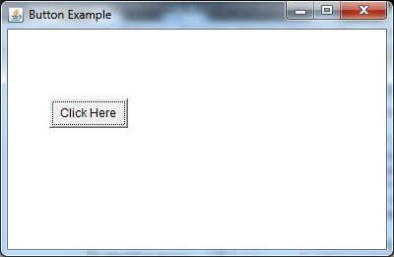

Java JTextField
The object of a JTextField class is a text component that allows the editing of a single line text. It inherits JTextComponent class.

JTextField class declaration
Let's see the declaration for javax.swing.JTextField class.
- public class JTextField extends JTextComponent implements SwingConstants

Commonly used Constructors:
Constructor | Description
JTextField() | Creates a new TextField
JTextField(String text) | Creates a new TextField initialized with the specified text.
JTextField(String text, int columns) | Creates a new TextField initialized with the specified text and columns.
JTextField(int columns) | Creates a new empty TextField with the specified number of columns.

Commonly used Methods:
Methods | Description
void addActionListener(ActionListener l) | It is used to add the specified action listener to receive action events from this textfield.
Action getAction() | It returns the currently set Action for this ActionEvent source, or null if no Action is set.
void setFont(Font f) | It is used to set the current font.
void removeActionListener(ActionListener l) | It is used to remove the specified action listener so that it no longer receives action events from this textfield.

Java JTextField Example
import javax.swing.*;
class TextFieldExample
{
public static void main(String args[])
{
JFrame f= new JFrame("TextField Example");
JTextField t1,t2;
t1=new JTextField("Welcome to Javatpoint.");
t1.setBounds(50,100, 200,30);
t2=new JTextField("AWT Tutorial");
t2.setBounds(50,150, 200,30);
f.add(t1); f.add(t2);
f.setSize(400,400);
f.setLayout(null);
f.setVisible(true);
}
}
Output:
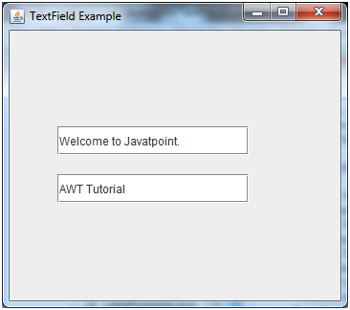

Java JTextField Example with ActionListener
import javax.swing.*;
import java.awt.event.*;
public class TextFieldExample implements ActionListener{
JTextField tf1,tf2,tf3;
JButton b1,b2;
TextFieldExample(){
JFrame f= new JFrame();
tf1=new JTextField();
tf1.setBounds(50,50,150,20);
tf2=new JTextField();
tf2.setBounds(50,100,150,20);
tf3=new JTextField();
tf3.setBounds(50,150,150,20);
tf3.setEditable(false);
b1=new JButton("+");
b1.setBounds(50,200,50,50);
b2=new JButton("-");
b2.setBounds(120,200,50,50);
b1.addActionListener(this);
b2.addActionListener(this);
f.add(tf1);f.add(tf2);f.add(tf3);f.add(b1);f.add(b2);
f.setSize(300,300);
f.setLayout(null);
f.setVisible(true);
}
public void actionPerformed(ActionEvent e) {
String s1=tf1.getText();
String s2=tf2.getText();
int a=Integer.parseInt(s1);
int b=Integer.parseInt(s2);
int c=0;
if(e.getSource()==b1){
c=a+b;
}else if(e.getSource()==b2){
c=a-b;
}
String result=String.valueOf(c);
tf3.setText(result);
}
public static void main(String[] args) {
new TextFieldExample();
} }

Output:
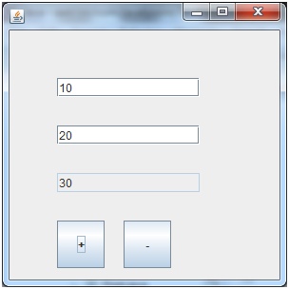
10s

Java Swing
Java Swing tutorial is a part of Java Foundation Classes (JFC) that is used to create window-based applications. It is built on the top of AWT (Abstract Windowing Toolkit) API and entirely written in java.
Unlike AWT, Java Swing provides platform-independent and lightweight components.
The javax.swing package provides classes for java swing API such as JButton, JTextField, JTextArea, JRadioButton, JCheckbox, JMenu, JColorChooser etc.

Difference between AWT and Swing
There are many differences between java awt and swing that are given below.
No. | Java AWT | Java Swing
1) | AWT components are platform-dependent. | Java swing components are platform-independent.
2) | AWT components are heavyweight. | Swing components are lightweight.
3) | AWT doesn't support pluggable look and feel. | Swing supports pluggable look and feel.
4) | AWT provides less components than Swing. | Swing provides more powerful components such as tables, lists, scrollpanes, colorchooser, tabbedpane etc.
5) | AWT doesn't follows MVC(Model View Controller) where model represents data, view represents presentation and controller acts as an interface between model and view. | Swing follows MVC.

What is JFC
The Java Foundation Classes (JFC) are a set of GUI components which simplify the development of desktop applications.

Hierarchy of Java Swing classes
The hierarchy of java swing API is given below.
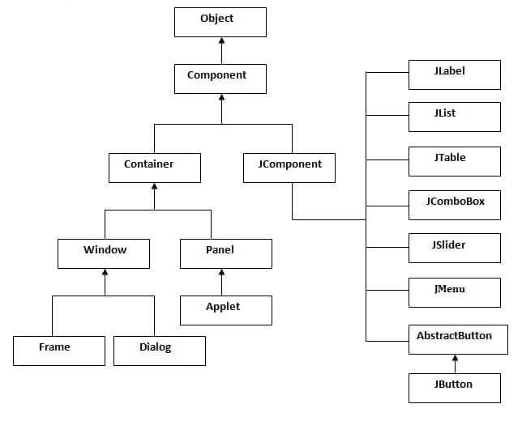

Commonly used Methods of Component class
The methods of Component class are widely used in java swing that are given below.
Method | Description
public void add(Component c) | add a component on another component.
public void setSize(int width,int height) | sets size of the component.
public void setLayout(LayoutManager m) | sets the layout manager for the component.
public void setVisible(boolean b) | sets the visibility of the component. It is by default false.

Java Swing Examples
There are two ways to create a frame:
- By creating the object of Frame class (association)
- By extending Frame class (inheritance)
We can write the code of swing inside the main(), constructor or any other method.

Simple Java Swing Example
Let's see a simple swing example where we are creating one button and adding it on the JFrame object inside the main() method.
File: FirstSwingExample.java
import javax.swing.*;
public class FirstSwingExample {
public static void main(String[] args) {
JFrame f=new JFrame();//creating instance of JFrame

JButton b=new JButton("click");//creating instance of JButton
b.setBounds(130,100,100, 40);//x axis, y axis, width, height

f.add(b);//adding button in JFrame

f.setSize(400,500);//400 width and 500 height
f.setLayout(null);//using no layout managers
f.setVisible(true);//making the frame visible
}



